Frinika
Milestone 4 - Design Patterns
Team member Student ID
Buthainah Aldosary 6302459
Jagdeep Singh 6449948
Luiz Mauricio Silva 6317006
Mischell Flor 5428483
Seun Odutola 6078109

TABLE OF CONTENTS

1. Design Patterns (Individual) 2
1.1. Author: Buthainah Aldosary (6302459) 2
1.2. Author: Seun Odutola (6078109) 5
1.3. Author: Luiz Mauricio Silva (6317006) 7
1.3.1. Design Pattern 1: Strategy 7
1.3.2. Design Pattern 2: Strategy 9
1.4. Author: Mischell Flor (5428483) 12
1.5. Author: Jagdeep Singh (6449948) 16

Design Patterns (Individual)

Author: Buthainah Aldosary (6302459)
Listener/ Observer pattern:
The purpose of the observer pattern is to define a one-to- many dependency between objects so that when one object changes state, all its dependents are notified and updated automatically (Gamma, Helm, Johnson, & Vlissides, 1995). The benefits of using the observer pattern are that it decreases coupling between classes and increases reusability. The following is a class diagram that shows the interacting classes. The classes ControllerView and PianoRoll are the Subject classes and implement a notify method (namely clientNotifySelectionChange() implemented from the PianoRollPanelAdapter abstract class). When this method is fired, it first gets the part selected and then notifies all its listeners who thus call the method selectionChanged() that repaints its Items. The observer pattern is important in Frinika’s GUI implementation to address extendibility of having more views in the future as well as to decouple classes from each other.
Reverse Engineering tools Used:
ModelGoon 4.4.1 was used as a plug in for the Eclipse IDE to draw class and sequence diagrams.
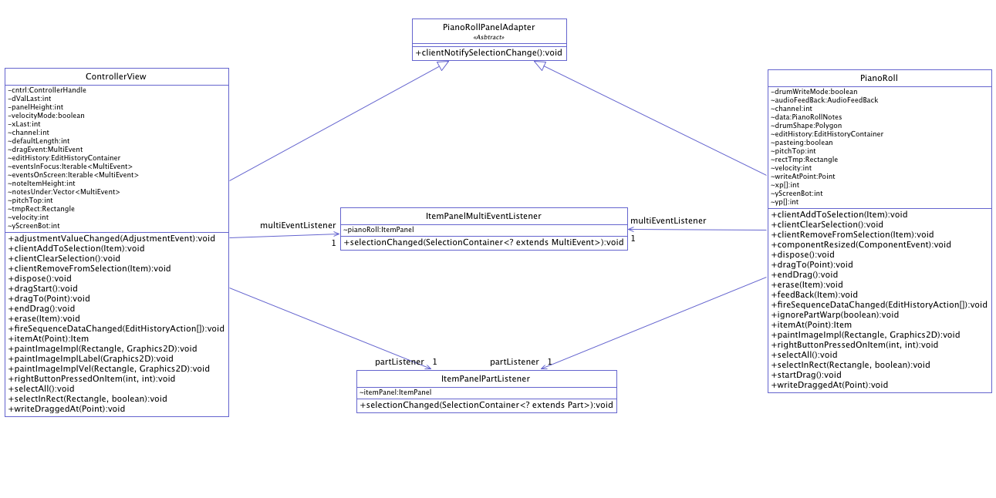
Figure 1: Class Diagram of Subject and Observer Classes.

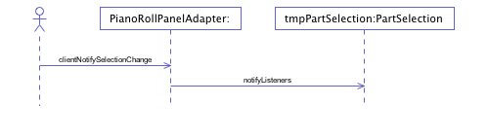
Figure 2: The clientNotifySelectionChange() method Sequence Diagram.
1- Subject Class: ControllerView
public class ControllerView extends PianoRollPanelAdapter implements AdjustmentListener {
int defaultLength;
int pitchTop = 127;
int noteItemHeight;
int yScreenBot;
……… }
2- Subject Class: PianoRoll
public class PianoRoll extends PianoRollPanelAdapter {
public static class PianoRollNotes {
private int noteItemHeight;
private Iterable<MultiEvent> notesOnScreen;
private Iterable<MultiEvent> notesInFocus;
private NoteEvent newNote;
……… }
3- Abstract Adapter Class Extended by both subject classes: PianoRollPanelAdapter
public abstract class PianoRollPanelAdapter extends ItemPanel implements EditHistoryListener,EventFilter
{
public void clientNotifySelectionChange() {
this.project.getPartSelection().notifyListeners(); } }
4- public class ItemPanelMultiEventListener implements SelectionListener<MultiEvent> { ItemPanel pianoRoll;
public void selectionChanged(SelectionContainer<? extends MultiEvent> src) {
pianoRoll.repaintItems(); }
5- public class ItemPanelPartListener implements SelectionListener<Part> {
ItemPanel itemPanel;
public void selectionChanged(SelectionContainer<? extends Part> src) { itemPanel.repaintItems(); } }

Author: Seun Odutola (6078109)
Recognized Pattern: Strategy Pattern
Reference: www.sourcemaking.com/design_patterns/strategy
Description:
The strategy design pattern was identified in a subsection of the Frinika System (as seen below). It was utilized to provide alternative ways to achieving the same objective.
To elaborate on this, based on the class diagrams it can be deduced that user interactions with the components of the system are monitored and historically logged in the system. Whenever changes are made to the system a notification based on the nature of the change is fired. This arouses the following question, how does the system know what part of its component has been altered and how does it handle the request? This is where the strategy pattern plays a significant role as it enables such request to be delegated (passed unto) the appropriate component so that such request is handled correctly. In our case the (Piano Roll Panel Adapter) class implements a functionality such as the (fire sequence data change) the class then extends itself to other sub classes that then implement the service offered by overriding it with their custom behaviour.
Code:
public interface EditHistoryListener {
public void fireSequenceDataChanged(EditHistoryAction[] edithistoryEntries);
}
public abstract class PianoRollPanelAdapter extends ItemPanel implements EditHistoryListener,EventFilter {..}
abstract public class ItemPanel extends JPanel implements SongPositionListener,
ComponentListener, Snapable {
public synchronized void componentResized(ComponentEvent arg0) { ... }
protected abstract void writePressedAt(Point p);
public abstract Item itemAt(Point p); }
public class ControllerView extends PianoRollPanelAdapter implements AdjustmentListener {
protected synchronized void writePressedAt(Point p) {...}
public void fireSequenceDataChanged(EditHistoryAction[] edithistoryActions) { repaintItems(); }
}
public class PianoRoll extends PianoRollPanelAdapter {
protected synchronized void writePressedAt(Point p) {...}
public void fireSequenceDataChanged(EditHistoryAction[] edithistoryActions) { repaintItems(); } }

Tools Used (Reverse Engineering): ObjectAid
Class Diagram:
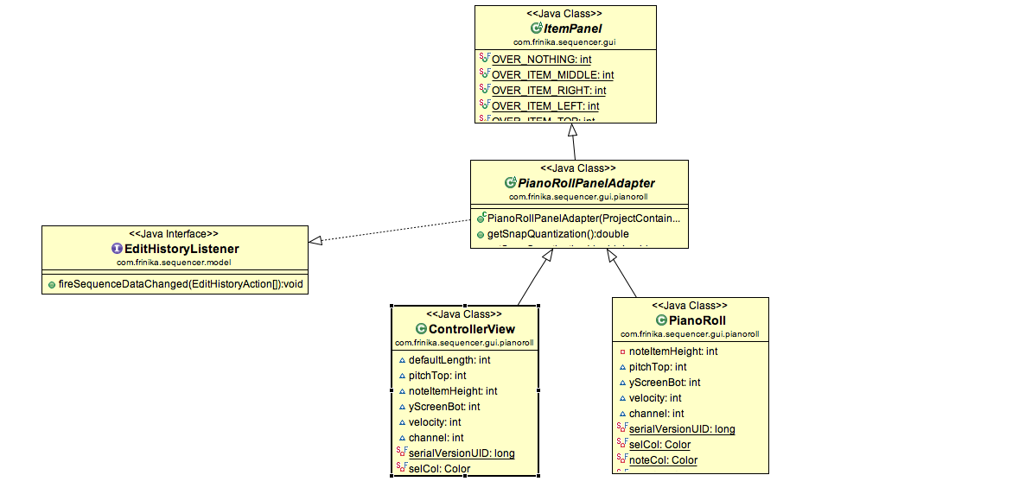

Author: Luiz Mauricio Silva (6317006)
In order to make the Design Pattern identification substantial, 2 patterns were identified in the package com.frinika.sequencer.gui.pianoroll.
The tools used to identify these patterns are described in table 1.3.T1:
# | Tool | Purpose
1 | Eclipse Indigo | IDE, used to browse the source code.
2 | Object Aid | Eclipse plugin to automatically generate class diagrams.
Table 1.3.T1: Tool used in the Design Pattern identification

Design Pattern 1: Strategy
As shown by the following Class Diagram, the interface PadPanelIF provides to other classes 3 operations / methods. It is needed to allow client classes (such as PadPanel) to be able to execute the defined interface without having to know if it is a VirtualPiano or a DrumPad.
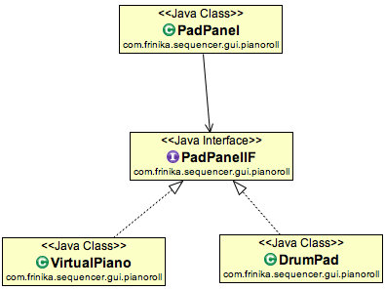
Figure 1.3.F1: Design Pattern Strategy – PadPanelIF. See SourceMaking website for a complete pattern description, http://sourcemaking.com/design_patterns/strategy.
PadPanelIF <<interface>>
Method | Description
resizeKeys() | Resize the keys of the instrument being used to edit a music track, either Piano or Drums.
paintComponent(Graphics g) | Paints a given component in the screen
getKey(Point point) | Gets the key of a given Point in the screen.
Table 1.3.T2: Methods of the interface PadPanelIF.
These methods are then implemented using different strategies / algorithms by the classes VirtualPiano and DrumPad. Excerpts of the source code that are relevant for the identified Design Pattern are presented.
PadPanelIF interface:
Interfaces resizeKeys(), paintComponent(Graphics g) and getKey (Point point) are defined.
interface PadPanelIF {
void resizeKeys();
void paintComponent(Graphics g);
Key getKey(Point point);
}
VirtualPIano class (first strategy/algorithm):
Interfaces previously defined are implemented to handle a virtual piano, with notes, black and white keys.
class VirtualPiano implements PadPanelIF {
Vector<Key> blackKeys = new Vector<Key>();
Vector<Key> whiteKeys = new Vector<Key>();
…
public void resizeKeys() {
blackKeys.clear();
whiteKeys.clear();
…
}
public void paintComponent(Graphics g) {

if (noteItemHeight != Layout.getNoteItemHeight())
…
}
public Key getKey(Point point) {
point.translate(0, -timePanelHeight + yScroll);
…
}
}

DrumPad class (second strategy/algorithm):
Interfaces previously defined are implemented for a second time to handle Drum “notes”, which are quite different from a piano.
class DrumPad implements PadPanelIF {
int noteItemHeight;
…
public void resizeKeys() {
noteItemHeight = Layout.getNoteItemHeight();
…
}
public void paintComponent(Graphics g) {

if (noteItemHeight != Layout.getNoteItemHeight())
…
}
public Key getKey(Point point) {
point.translate(0, -timePanelHeight + yScroll);
…
}
}

Design Pattern 2: Strategy
As shown by the following Class Diagram, the class LaneView provides to other classes 1 operation / method. It is needed to allow client classes to display lane buttons according to the type of the lane created (AudioLane, TextLane, SynthLane, MidiVoice or Project).
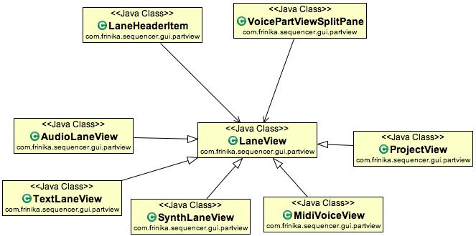
Figure 1.3.F2: Design Pattern Strategy – LaneView. See SourceMaking website for a complete pattern description, http://sourcemaking.com/design_patterns/strategy.
LaneView
Method | Description
makeButtons() | Resize the keys of the instrument being used to edit a music track, either Piano or Drums.
Table 1.3.T3: Methods of LaneView.

LaneView:
Interface makeButtons() is defined.
public class LaneView extends JPanel {
…
/**
* defualt lane has no buttons. OVERRIDE please
*
*/
protected void makeButtons() {

}
}

AudioLaneView class:
makeButtons() is implemented to display buttons specific for an audio lane.
public class AudioLaneView extends LaneView {
…
protected void makeButtons() {

JComponent but = createDeviceSelector();
add(but, gc);
gc.weighty = 1.0;
add(new Box.Filler(new Dimension(0, 0),
new Dimension(10000, 10000),
new Dimension(10000, 10000)),
gc);
}
}

SynthLaneView class:
makeButtons() is implemented to display buttons specific for a synthesizer lane.
public class SynthLaneView extends LaneView {
…
protected void makeButtons() {

makeHeader();
…
}
}

MidiVoiceView class:
makeButtons() is implemented to display buttons specific for an midi voice.
public class MidiVoiceView extends LaneView {
…
protected void makeButtons() {

JPanel devP = new JPanel();
…
}
}

The classes ProjectView and TextLaneView also implement different algorithms for the interface makeButtons(), however to avoid this document to be repetitive and with too much source code, those were kept out.

Author: Mischell Flor (5428483)
Since most of the design patterns are already been identified by my group mates and since Frinika did not used a lot of design pattern. My goal is to provide additional patterns that would be useful in Frinika such as Builder Pattern and Singleton
Builder pattern separates the construction of a complex object from its representation so that the same construction process can create different representations. Singleton pattern ensures a class has only one instance and encapsulated as “just-in-time initialization”.
In Frinika, the package Com.frinika.sequencer.gui.menu contains multiple classes for menu items (See figure 1) and these objects are all created in ProjectFrame.java (See figure 2)
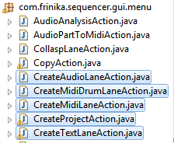
Figure 1
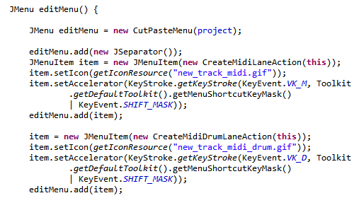
Figure 2

As we can see, the class ProjectFrame handles all the construction of the menus. This leads to large class and high coupling and low cohesion. In addition, it does a lot of objects construction that can be complex like combining multiple menu items to create another menu. This complex construction calls for builder design pattern and singleton.
The intent of the Builder design pattern is to separate the construction of a complex object from its representation. By doing so, the same construction process can create different representations. See Figure 3 for class diagram
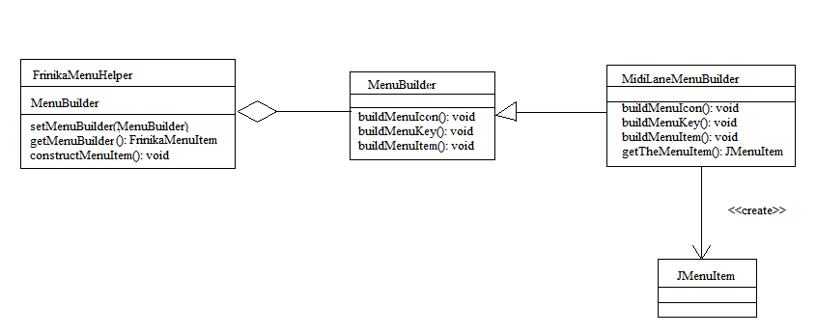
FrinikaMenuHelper constructs the menu item
MenuBuilder is an abstract interface that has three abstract methods for building a menu item
MidiLaneMenuBuilder is an example of concrete class. It implements the abstract methods from MenuBuilder.
The code below shows the implementation of builder pattern for Frinika
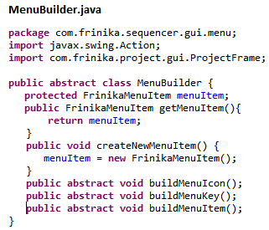
Note: This class may use singleton pattern to ensure that only one instance of builder will be created
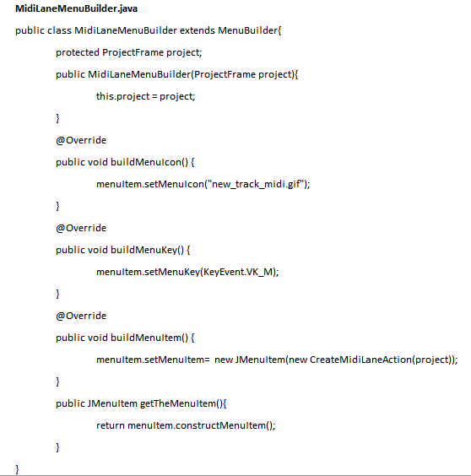
Note: The class MidiLaneMenuBuilder can be used as a template to create another concrete class like MidiDrumLaneMenuBuilder.java and others
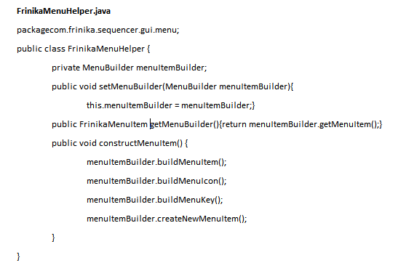
References:
http://sourcemaking.com/design_patterns/builder
http://sourcemaking.com/design_patterns/singleton

Author: Jagdeep Singh (6449948)

Using two tools ‘object aid’ and ‘web of templates’ I was not able to identify any different architecture design pattern.
So manually I found observer pattern.
Multiple events are called upon change in event ev . When interface with the event changed, it corresponds the change in following classes.
This reduces the coupling as rather than collecting all the events in same class, they are separated and called upon when required. So it provides ‘low coupling’.

Code:
Multieventesditpanel.java
public void selectionChanged(SelectionContainer<? extends MultiEvent> src) {
……………
MultiEvent ev = project.getMultiEventSelection().getFocus();
if (event == ev)
…………

Multieventmodel.java
public MultiEventTableModel(ProjectContainer project,MultiEvent note, int quantize, int ticksPerBeat) {

…………
}

void setMultiEvent(MultiEvent ev) {
this.event = ev;
}

